**CHATBOT USING OPENAI *A project submitted in partial fulfillment of the requirements for the degree of  
  
BACHELOR OF TECHNOLOGY IN COMPUTER SCIENCE AND ENGINEERING   
  
by  
  
AYUSH KUMAR- 12022002001143   
  
 ANKUSH KUMAR MALLICK- 12022002001136  
  
 ABHIJON CHATTERJEE- 12022002001145   
 under the guidance of  
Prof. MR PRAVESH BANSAL  
***

**Department of Computer Science and Engineering**

**University of Engineering and Management**

***Udaipuria Mod, Sikar Road,  
Jaipur-303807***

**ACKNOWLEDGEMENT**

**The endless thanks goes to Lord Almighty for all the blessings he has showered onto us, which has enabled us to write this last note in my research work. During the period of our research, as in the rest of our life, we have been blessed by Almighty with some extraordinary people who have spun a web of support around me. Words can never be enough in expressing how grateful we are to those incredible people in our life that made this thesis possible. We would like an attempt to thank them for making my time during our research in the Institute a period we will treasure. We are deeply indebted to our research supervisor, Professor Guide Name for giving us such an interesting thesis topic. Each meeting with him added in valuable aspects to the implementation and broadened our perspective. He has guided us with his invaluable suggestions, lightened up the way in our darkest times and encouraged us a lot in the academic life.**   
   
   
   
   
**Candidate   
Name  
Ayush Kumar (12022002001143)  
Ankush Kumar Mallick(12022002001136)  
Abhijon Chatterjee(12022002001145)**

**Approval Certificate**

**This is to certify that the project report entitled “CHATBOT USING OPENAI”**, **submitted by Ayush kumar, Abhijon Chatterjee, Ankush Kumar Mallick (12022002001143, 12022002001145, 12022002001136) in partial fulfillment of the requirements of the degree of Bachelor of Technology in Computer Science & Engineering from University of Engineering and Management, Jaipur was carried out in a systematic and procedural manner to the best of our knowledge. It is a bona fide work of the candidate and was carried out under our supervision and guidance** **during the academic session of 2022-2026.**

_______________________

**Prof. Pravesh Kumar Bansal**

Project Guide, Assistant Professor (CSE)

UEM, JAIPUR

_______________________ ______________________

**Prof. Mrinal Kanti Sarkar Prof. A Mukherjee**

HOD (CSE), Dean,

UEM, JAIPUR UEM, JAIPUR

**OVERVIEW:**

**Table of Contents**

**List of Figures**

**CHAPTER**

* **INTRODUCTION**
* **HISTORY**
* **LITERATURE REVIEW**
* **PROPOSED WORKS AND ALGORITHMS**
* **VISUALIZATION VIA FLOWCHART**
* **RESULT ANALYSIS**
* **CONCLUSION AND FUTURE SCOPE OF CHATBOT**
* **REFERENCES**

**INTRODUCTION:**

* ***A chatbot is a program that communicates with you.***
* ***It is a layer on top of, or a gateway to, a service. Sometimes it is powered by machine learning (the chatbot gets smarter the more you interact with it). Or, more commonly, it is driven using intelligent rules (i.e. if the person says this, respond with that).***
* ***The services a chatbot can deliver are diverse. Important life-saving health messages, to check the weather forecast or to purchase a new pair of shoes, and anything else in between.***
* ***The term chatbot is synonymous with text conversation but is growing quickly through voice communication.***
* ***The chatbot can talk to you through different channels; such as Facebook Messenger, Siri, WeChat, Telegram, SMS, Slack, Skype and many others.***
* ***Consumers spend lots of time using messaging applications (more than they spend on social media). Therefore, messaging applications are currently the most popular way companies deliver chatbot experiences to consumers.***

**HISTORY:**

***Alan Turing in 1950 proposed the Turing Test (“Can machines think?”), and it was at that time that the idea of a chatbot was popularized. The first known chatbot was Eliza, developed in 1966, whose purpose was to act as a psychotherapist returning the user Utterances in a question form. It used simple pattern matching and a template***. ***Based response mechanism. Its conversational ability was not good, but it was enough to confuse people at a time when they were not used to interacting with computers and give them the impetus to start developing other chatbots. An improvement over ELIZA was a chatbot with a personality named PARRY developed in 1972. In 1995, the chatbot ALICE was developed which won the Loebner Prize, an annual Turing Test, in years 2000, 2001, and 2004. It was the first computer to gain the rank of the “most human computer”. ALICE relies on a simple pattern-matching algorithm with the underlying intelligence based on the Artificial Intelligence Markup Language (AIML) , which makes it possible for developers to define the building blocks of the chatbot Knowledge . Chatbots, like Smarter Child in 2001, was developed and became available through messenger applications. The next step was the creation of virtual personal assistants like Apple Siri, Microsoft Cortana, Amazon Alexa, Google Assistant and IBM Watson. According to Scopus, there was a rapid growth of interest*** in ***chatbots especially after the year 2016. Many chatbots were developed for industrial Solutions while there is a wide range of less famous chatbots relevant to research and their applications.***

**LITERATURE REVIEW:**

* ***Chat bot mediated learning is also considered as a branch of TML (Technology Mediated Learning) where the study is personalized and students can dynamically use these bots for their learning. The chatbots assess the discernment of the students and provides the subsequent lecture. For instance, the Summit Learning Project uses chatbots to identify the weak areas of students and adapt to their leaning style and help them manage the modules. The chatbots further conducts quizzes and submits the results to the tutors, who provide immediate feedback to the students. This is accomplished through digital forums.***
* ***Apart from standalone chatbots, there has been an increase in the integration of these chatbots in social platforms such as Facebook, Google classroom and so on. Based on the category, language and development platform chatbots used for education in Facebook has been studied in and the efficacy has been evaluated. Quality allocation was tabulated using Analytic Hierarchy Process (AHP).***
* ***Chatbot only simplifies task for tutors by helping students with frequent queries and assessing them personally. Teacher can equip themselves with the latest research during the supplementary time they get.Ashok Goel, is one among the initial educators who used this method and developed his own chat bot and named Jill Watson. It attempted to answer the students through an online forum dispensing all available information including technical doubts.***
* ***Several taxonomies are used in the literature to classify chatbots. Hussain categorized chatbots based on their purpose as task-oriented and non-task-oriented. The primary function of a task-oriented chatbot is to respond to domain-specific user queries and often perform tasks such as reserving a ticket. A non-task-oriented chatbot interacts with humans in open-ended, domain-specific conversations, also called open-domain chatbots. The primary function of these chatbots is to act as virtual companions where the dialog is open-ended.***

**PROPOSED WORKS AND ALGORITHMS:**

* ***The first chat bot with ELIZA name was constructed in 1966. ELIZA simulated a psychotherapist’s operation, returning the user’s sentences in the interrogative form. Its ability to communicate was limited, but it was a source of inspiration for the subsequent development of other chatbots. ELIZA uses pattern matching and a response selection scheme based on templates. A drawback of ELIZA is that its knowledge is limited, and therefore, it can discuss only in a particular domain of topics. Also, it cannot keep long conversations and cannot learn or discover context from the discussion.***
* ***In 1972, PARRY appeared; It acted as a patient with schizophrenia. PARRY is considered more advanced than ELIZA is as it is supposed to have a “personality” and a better controlling structure. PARRY was used in an experiment in 1979 when five psychiatrist judges interviewed by teletype a patient to decide whether he was a computer program or a real schizophrenic patient. Therefore, psychiatrists gave ten diagnoses. The first psychiatrist gave two correct diagnoses; another gave two incorrect ones. The third considered that both subjects were real patients, and the other two diagnosed that both subjects were chat bots. However, the sample of five psychiatrists is small, and the meaning of the findings is not clear as people with schizophrenia have a degree of incoherence in their speech. In general, PARRY is considered a chat bot with low capabilities which has a low speed of responding, and it cannot learn from the conversation.***
* ***Another step forward in the history of chat-bots was the creation, in 1995, of ALICE the first online chat-bot inspired by ELIZA. ALICE was based on pattern-matching, without any actual perception of the whole conversation but with discussion ability on the web that allowed longitude and included any topic. Artificial Intelligence Markup Language (AIML), which is the most critical difference between ALICE and ELIZA. ALICE’s Knowledge Base consisted of about 41,000 templates and related patterns, a vast number comparing to ELIZA that had only 200 keywords and rules. However, ALICE did not have intelligent features and could not generate human-like answers expressing emotions or attitudes.***
* ***In 2011, a chatbot called Watson was created by IBM. Watson could understand the natural human language well enough to win two previous champions on the quiz competition “Jeopardy”, in which participants received some information in the form of answers and should guess the corresponding questions. Years later, Watson enabled businesses to create better virtualassistants. Moreover, Watson Health was designed to help doctors in healthcare diagnose diseases. However, a drawback of Watson is that it supports only English.***
* ***Microsoft designed a personal assistant Cortana developed in 2014 (Personal Digital Assistant—Cortana Home Assistant—Microsoft, 2019). It recognizes voice commands and performs tasks such as identification of time and position, support people-based reminders, send emails and texts, create and manage lists, chitchat, play games, and find information the user requests. The major drawback of Cortana that has been reported is that it can run a program that will install malware.***

**VISUALIZATION VIA FLOWCHART:**

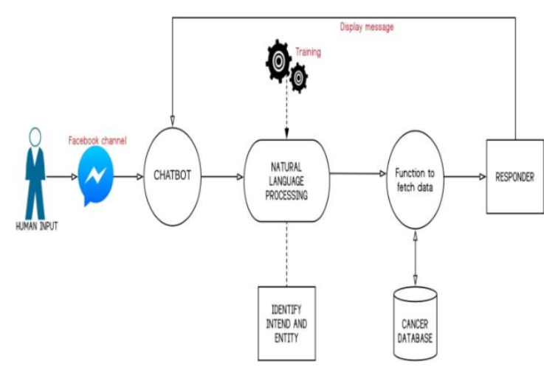

***Fig: Functioning of a Chatbot***

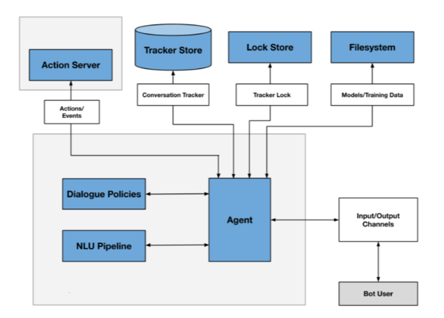

***Fig: Working of Natural language processing and Dialogue policies***

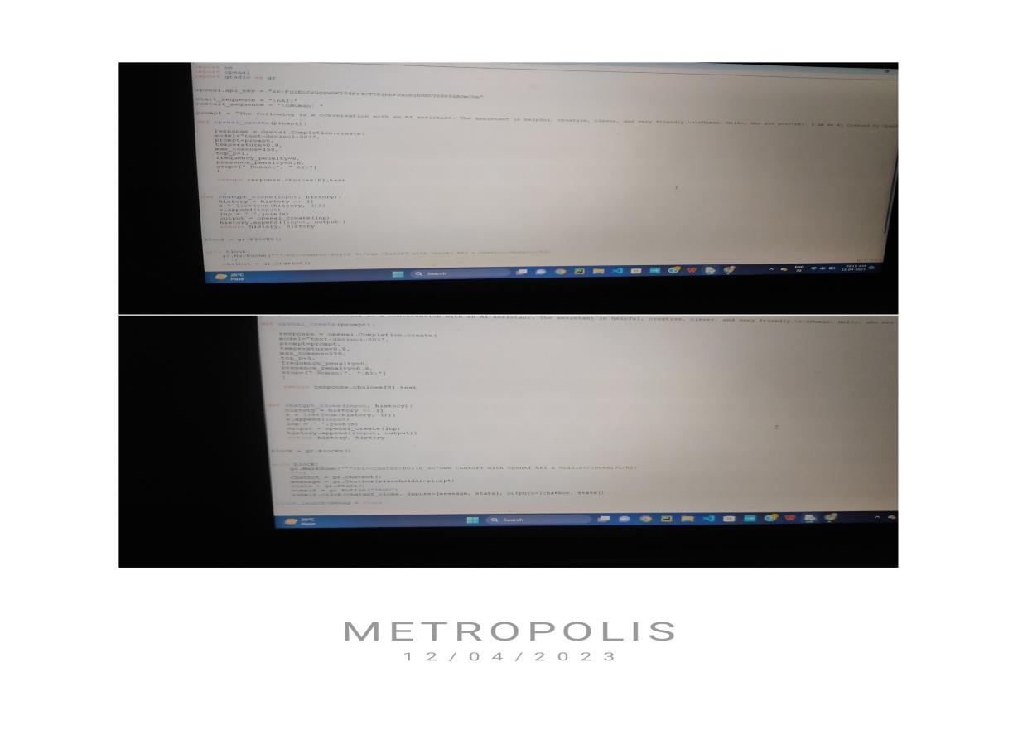**RESULT ANALYSIS:**

***FIGURE 1: SOURCE CODE***

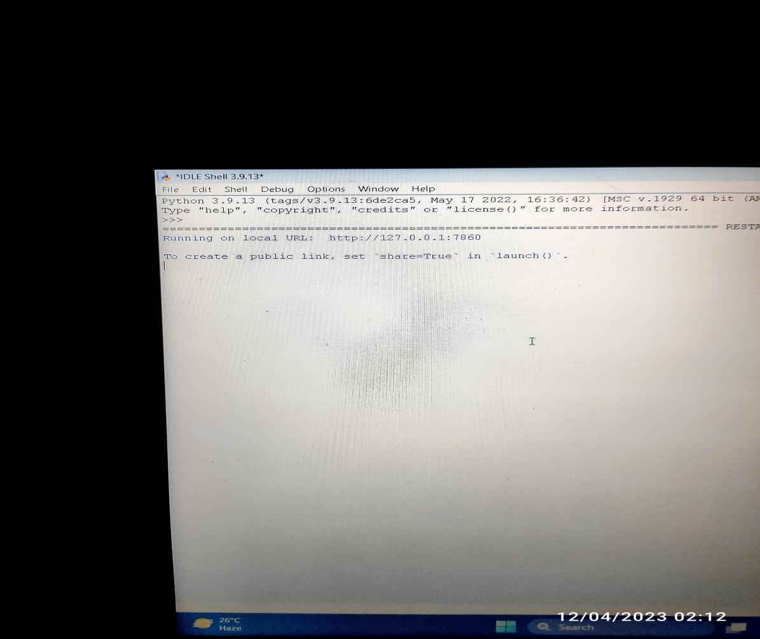

***FIGURE 2: OUTPUT***

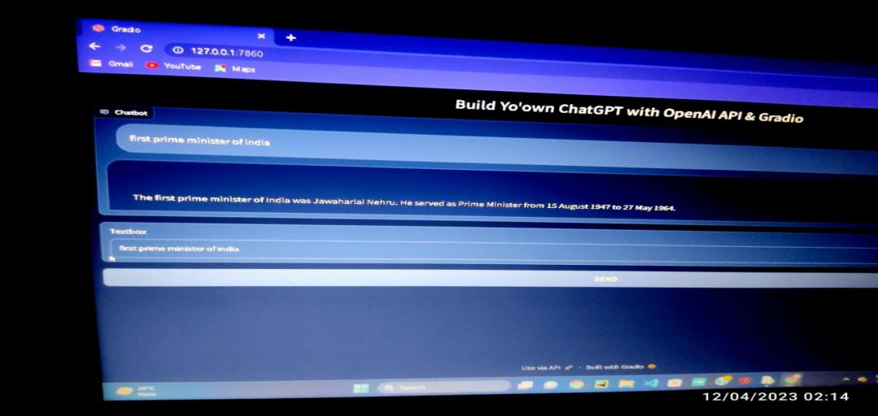

***FIGURE 3: CHATBOT STRUCTURE***

**CONCLUSION AND FUTURE SCOPE OF CHATBOT:**

***From our perspective, chatbots or smart assistants with artificial intelligence are dramatically changing businesses. There is a wide range of chatbot building platforms that are available for various enterprises, such as e-commerce, retail, banking, leisure, travel, healthcare, and so on. Chatbots can reach out to a large audience on messaging apps and be more effective than humans. They may develop into a capable information-gathering tool in the near future. According to Juniper Research, by 2023, chatbots will help retail, banking, and healthcare industries save $11 billion solely on customer service inquiries, with over 2.5 billion hours saved. Additionally, out of these sectors, the retail industry will be able to maximize the use of chatbots by 70% to assist with customer inquiries. Not only will chatbots help with customer interactions on brand’s websites, but there will be more use within brand’s apps, with 50% of the chatbot usage through apps.They can assist the IT help desk and customer service employees by learning to answer the repetitive questions customers ask and improve response time. Internally, they can collect and organize information to help with human resource duties such as on boarding and gathering valuable updates on employees. When discussing chatbots on the SEJ Today podcast, Dr. Michelle Zhou, co-founder and CEO of Juji, Inc. and the inventor of IBM Watson Personality Insights, said chatbots are improving and can help give personalized information based on conversation. Chatbots are moving to more intuitive conversations versus simple run-of-the-mill responses. In addition, chatbots are transforming to use NLP to better understand and send accurate answers to users. She continues discussing chatbot improvements, focusing on their importance for small businesses. For example, since it’s not possible to hire numerous people for all the functions and customer service components needed to scale a business, chatbots can become virtual assistants to help with mundane or repetitive processes so employees can focus on other areas throughout the company.***

**REFERENCES:**

1. **<https://en.wikipedia.org/wiki/chatbot>**
2. **<https://sproutsocial.com/insights/topics/chatbots/>**
3. **<https://chatbotsmagazine.com/a-visual-history-of-chatbots-8bf3b31dbfb2>**
4. **<https://youtu.be/n5nn3mQxrE8>**